**Part B. Interpretation of a Confidence Interval**

**1.** z with sigma, n = 100, intervals = 30

|  |  |  |  |
| --- | --- | --- | --- |
| Sample | Intervals containing μ | Running total | Diagram showing all intervals |
| 1 | 28 / 30 = 93.3% | 28 / 30 = 93.3% |  |
| 2 | 27 / 30 = 90.0% | 55 / 60 = 91.7% |  |
| 3 | 30 / 30 = 100.0% | 85 / 90 = 94.4% |  |
| 4 | 29 / 30 = 96.7% | 114 / 120 = 95.0% |  |
| 5 | 27 / 30 = 90.0% | 141 / 150 = 94.0% |  |
| 6 | 28 / 30 = 93.3% | 169 / 180 = 93.9% |  |
| 7 | 29 / 30 = 96.7% | 198 / 210 = 94.3% |  |
| 8 | 27 / 30 = 90.0% | 225 / 240 = 93.8% |  |
| 9 | 28 / 30 = 93.3% | 253 / 270 = 93.7% |  |
| 10 | 29 / 30 = 96.7% | 282 / 300 = 94.0% |  |

**2.** The “Running Total” after the 4th sample was exactly 95.0%. This was the only occurrence of that number. However, this does not indicate any problem with the calculations done in the applet. There will always be some randomness in the data, so we should not expect all or even most of the Running Totals to be exactly 95%. As for the “Interval containing μ”, because the n was 30, and 95% of 30 is not a whole number, it would be impossible for this value to ever be exactly 30%.

**3.** t, n = 100, intervals = 107

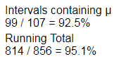

In this circumstance, 856 is mathematically large. This is how many intervals were necessary to get the percentage of Running Total close to 95%.

**4.** n = 5, intervals = 10

**a.**

|  |  |  |
| --- | --- | --- |
| z with sigma | z with s | t |
|  |  |  |

**b.**

|  |  |  |
| --- | --- | --- |
| z with sigma | z with s | t |
|  |  |  |

**c.** In the “z with sigma” figures, the confidence intervals are all of the same size or range. This is clear because the lines are all the same length. However, in the “z with s” figures, the confidence intervals vary greatly in size/range, as is clear by the variety of short and long lines. This is because the population standard deviation, sigma, is constant, while the sample standard deviation, s, is variable from sample to sample.

**d.** While both the “z with s” and the “t” figures show varying lengths of lines, and therefore varying sizes of confidence intervals, the “t” figures show generally longer lines, or wider confidence intervals, than the “z with s” figures. This is most likely because, while both rely on the sample standard deviation, s, “t” values are generally greater than “z” values.

**5.** In this design, the study unit is the data set; the treatment levels are z with sigma, z with s, and t; and the response is the resultant Confidence Intervals. This design is preferable for using a new sample for each new set of Confidence Intervals because we can see how, for the exact same data, the different models result in different Confidence Intervals; if we were using six samples for six graphs, it would be hard to tell what differences arose from differences in the models and what differences were due to differences in the samples themselves.

**Part C. Interpretation of Power**

**1.** n = 20, μ0 = 500, σ = 75

**a.** α = 0.01, μa = 550

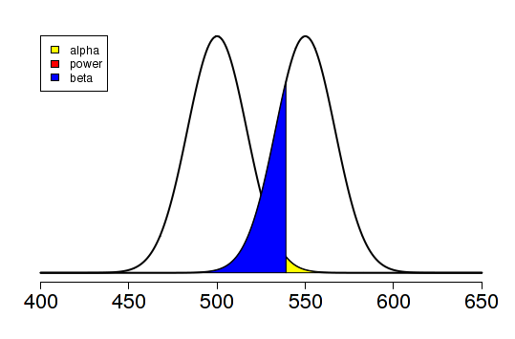

**b.** α = 0.05, μa = 550

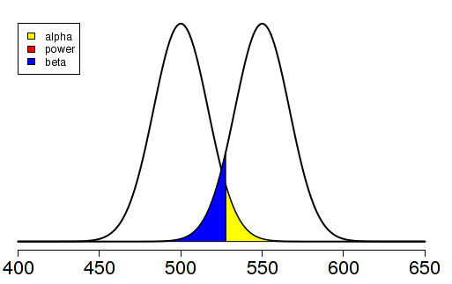

**c.** α = 0.01, μa = 575

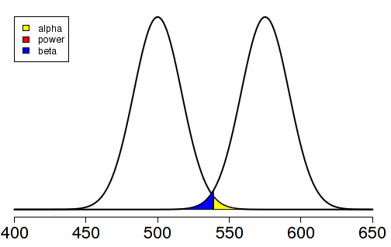

**d.** n = 10, α = 0.01, μa = 550

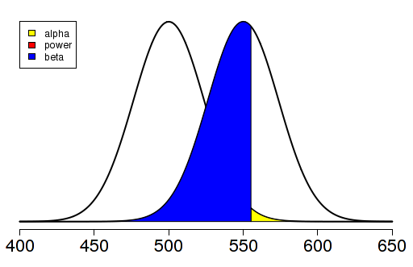

**2.** Increasing the significance level (from part a to part b) resulted in a larger alpha region and a smaller beta region. Increasing the alternative mean (from part a to part c) moved the alternative distribution right, resulting in a smaller beta region. The alpha region remained the same size. Decreasing the sample size resulted in wider distributions, and thus a larger beta region. The alpha region remained the same size.

**3.** **a.** n = 10, α = 0.01, μa = 550

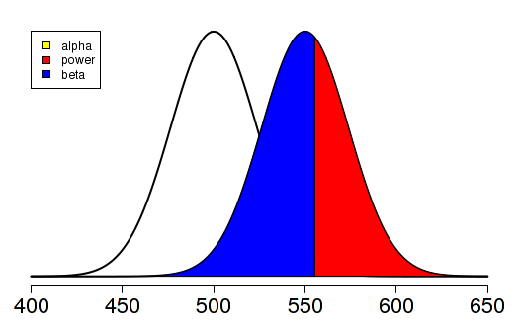

**b.** Power + β = 1

**4.** α = 0.01, μa = 530 🡪 find n s.t. $β≈0.01=α$

Result: n = 135

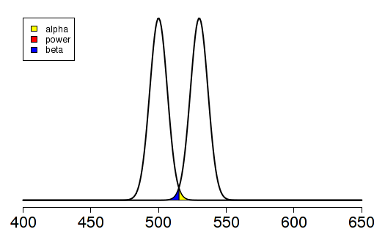

**5.** For α, Ho is assumed to be true.

For β, Ha is assumed to be true.

For power, Ha is assumed to be true.